**A**

**Project Report**

**On**

### DEPARTMENT DESK - A PORTAL FOR DEPARTMENT ADMINISTRATION AND MANAGEMENT

Submitted in partial fulfillment of the requirement for award of the degree of

### MASTER OF COMPUTER APPLICATIONS

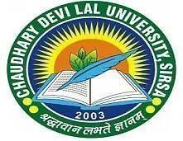**(Session-2023-2025)**

**UNDER THE SUPERVISION OF: SUBMITTED BY:**

Dr. Kuldeep Kumar Mohit

Assistant Professor MCA (4th-Sem)

Dept. of Computer Sc. & Eng. Reg. No.23111990870019

**DEPARTMENT OF COMPUTER SCIENCE AND ENGINEERING**

## **CHAUDHARY DEVI LAL UNIVERSITY, SIRSA-125055**

## **(JUNE 2025)**